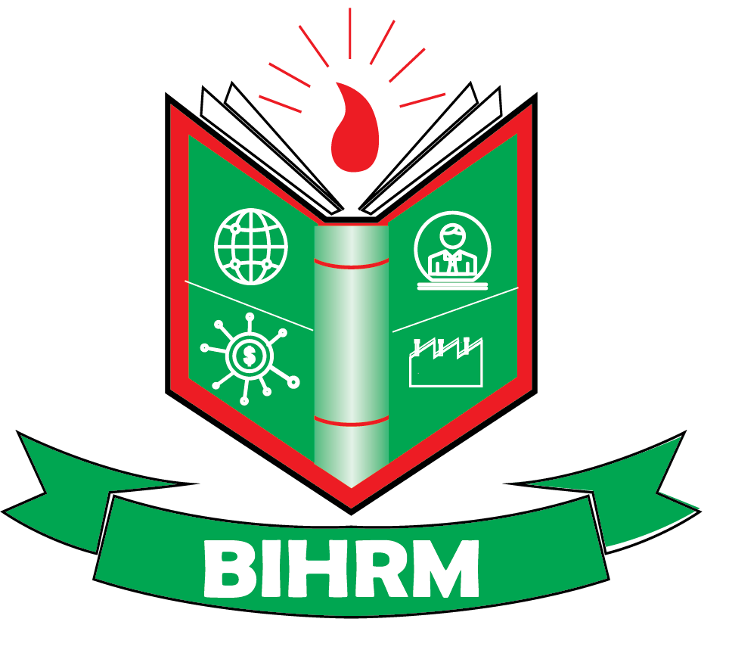
Bangladesh Institute of Human Resource Management (BIHRM)
(An Autonomous Professional institute, govt. Approved)
Farmgate building: 71 center Tejkunipara, Honda street, , Uttara: sector 4, road 7 house 115
www.bihrm.org,E-mail: infor@bihrm.org, bihrmbd@gmail.com
Course:
Roll:
Admission Form

1.Name (capital letter)_________________________________________________________
2.Father’s Name: _____________________________________________________________
3.Mother’s Name: __________ Profession: ________________________________________
4.Spouse: ________________Profession: N/A______________________________________
5.Date of Birth: ______________________6. Place of Birth: __________________________
7. Mailing Address : __________________________________________________________
___________________________________________________________________________
8. E-mail: ___________________________________ Mobile1: _______________________
9. NID Id: ____________________________________Mobile2: _______________________

9.Educational Information:
SL | Name of Exam | Board/Institute/University | Passing Year | Grade/Division/CGPA
1
2
3
5
10. Employment: Employed Un Employed

If Employed, Name & Address of the organization: _________________________________
___________________________________________________________________________
Designation: Position:
11.Work Experience :
SL. | Position | Duration | Organization
a
b
12.How do you Know about this course? ______________________________________
From /LinKedin/Facebook______________ Others: _________________________________

Student’s Signature Date:

